**Submitted to: Dr. Devon Lin**

**Submitted by: -Hardik Uppal**

**Student number: -20132445**

STAT862

Assignment 2

1. **Consider the Auto dataset in the R package ISLR. Consider predicting the vehicles acceleration time based on the horsepower of its engine**
2. **Looking at the scatter plot of acceleration vs horsepower, choose some knots and fit a regression spline.**

|  |
| --- |
| library(ISLR)  attach(Auto)  xyplot(acceleration~horsepower,xlab = "Horsepower",ylab = "Acceleration")  library(splines)  myPanel <- function(...)  {  panel.smooth(...)  panel.xyplot(...,alpha=.5)  }  panel.smooth <- function(x,y,...)  {  knots=quantile(x,c(1/3,2/3))  fit = lm(y~bs(x,knots=knots,degree=3))  x0 = seq(min(x),max(x),len=101)  llines(x0,predict(fit,data.frame(x=x0)),col="black")  lsegments(x0=knots[1],y0=min(y),x1=knots[1],y1=max(y),col="black",lty=2)  lsegments(x0=knots[2],y0=min(y),x1=knots[2],y1=max(y),col="black",lty=2)  }  xyplot(acceleration~horsepower,Auto,panel=myPanel) |



Looking at the scatter plot we can see there is a negative correlation between the two variables. Also we can see there is more density at one place and the ends are less dense. We choose the knots at the quantiles

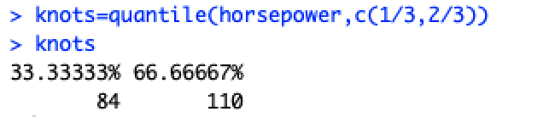

where the density is more and behaviour seems to change.



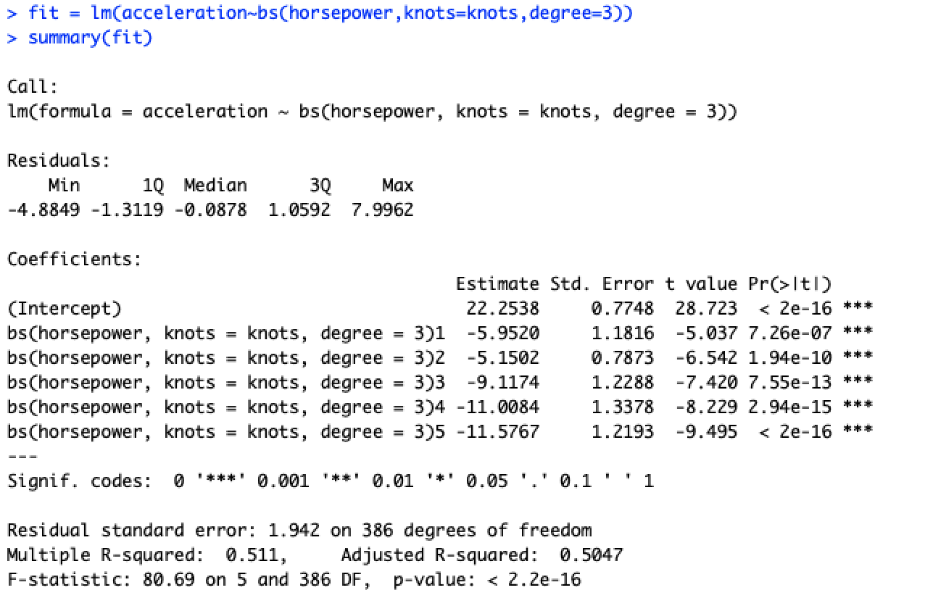

**(b) Fit a smoothing spline, selecting the smoothing parameter by cross-validation**

|  |
| --- |
| plot(acceleration~horsepower, data=Auto,xlab = "Horsepower",ylab = "Acceleration")  smoothing.param=smooth.spline(horsepower,acceleration,cv=T)  smoothing.param$lambda  summary(smoothing.param)  smoothing.param$cv.crit  lines(smoothing.param, col="blue") |



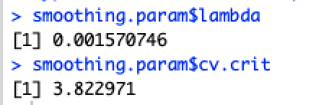

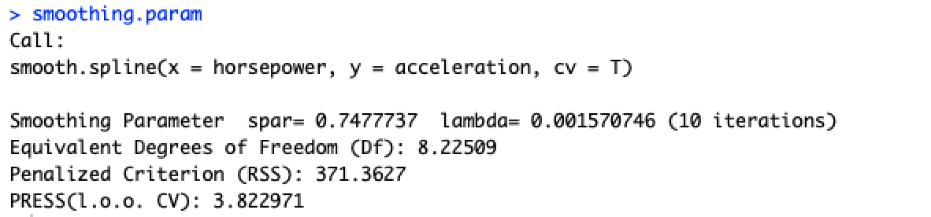

The smoothing spline is fitted with CV=True for leave one out cross validation.

The lambda comes out as 0.001570746 and degree of freedom is 8.22509

**c) In one figure, make a plot of data, the resulting fitted line from both (a) and (b). Estimate its prediction mean- squared error by some cross-validation technique. Which approach resulted in the best prediction accuracy?**

|  |
| --- |
| fit = glm(acceleration~bs(horsepower,knots=knots,degree=3))  summary(fit)  mse.rs= cv.glm(Auto,fit)$delta[1]  plot(acceleration~horsepower, data=Auto,xlab = "Horsepower",ylab = "Acceleration")  lines(smoothing.param, col="blue")  lines(sort(horsepower),fitted(fit)[order(horsepower)], col="red")  legend("topright",legend=c("Regression spline","smoothing spline") ,col=c("red","blue") , lty =1 , lwd =2 , cex =.8) |



**MSE for smoothing spline is 3.822971**



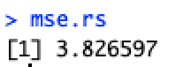

**MSE for regression spline is 3.826597**

**We can see that the mse error for smoothing spline is less when both the cross validation are LOOCV. But the difference is not significant.**

1. **Consider the data set Boston in the R package ISLR. We treat dis as the predictor and nox as the response variable**

(**a) Fit a cubic polynomial regression to predict nox using dis. Report the regression output, and plot the resulting data and polynomial fits.**

|  |
| --- |
| attach(Boston)  Boston  range(dis)  poly.fit=lm(nox~poly(dis,3))  summary(poly.fit)  plot(ploy.fit)  plot(dis, nox)  lines(sort(dis), fitted(poly.fit)[order(dis)], col='red', type='b') |

**The cubic polynomial fit is as below**

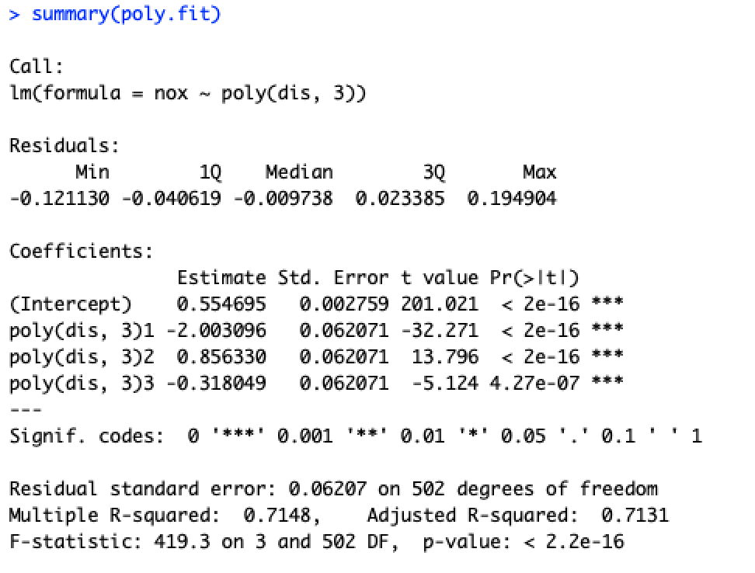

**The coefficients are intercept- 0.554, x—2.0030, x^2-0.8563, x^3—0.3180**



**(b) Plot the polynomial fits for a range of different polynomial degrees (say, from 1 to 10), and report the associated residual sum of squares**

|  |
| --- |
| cv.err= rep(NA,10)  color=c("red","blue","green","yellow","black","grey","orange","brown","pink","purple")  plot(dis, nox)  for (i in 1:10){  fit = glm(nox~poly(dis,i),data=Boston)  lines(sort(dis), fitted(fit)[order(dis)], col=color[i])  cv.err[i] = sum(fit$residuals^2)    }  legend("topright",legend=c("polynomial 1st degree","polynomial 2nd degree","polynomial 3rd degree","polynomial 4th degree","polynomial 5th degree","polynomial 6th degree","polynomial 7th degree","polynomial 8th degree","polynomial 9th degree","polynomial 10th degree") ,col=c("red","blue","green","yellow","black","grey","orange","brown","pink","purple") , lty =1 , lwd =2 , cex =.8)  cv.err  point_min=which.min(cv.err)  plot(1:10, cv.err, xlab = "Degree", ylab = "Test MSE", type = "l")  points(point_min,cv.err[point_min], col="red") |

**The 10 degree of polynomial is plot as below :-**





The residual sum of squares is given



The cross validation error decreases with the degrees and the minimum cross validation error is at 10th degree

**(c) Perform 5-fold cross-validation to select the optimal degree for the polynomial, and explain your results.**

|  |
| --- |
| cv.error=seq(1,10)  for (i in 1:10){  glm.fit=glm(nox~poly(dis,i),data=Boston)  cv.error[i]=cv.glm(Boston,glm.fit,K=5)$delta[1]  }  cv.error  point_min=which.min(cv.error)  plot(1:10, cv.error, xlab = "Degree", ylab = "Test MSE", type = "l")  points(point_min,cv.error[point_min], col="red") |





We can see the minimum cross validation error is at 9th degree 0.00384

**(d) Fit a regression spline to predict nox using dis. Report the output for the fit using four degrees of freedom. How do you choose the knots? Plot the resulting fit.**

|  |
| --- |
| xyplot(nox~dis,Boston)  myPanel <- function(...)  {  panel.smooth(...)  panel.xyplot(...,alpha=.5)  }  panel.smooth <- function(x,y,...)  {  #knots=quantile(x,c(1/3,2/3))  fit = lm(y ~ bs(x,df=4))  summary(fit)  x0 = seq(min(x),max(x),len=101)  llines(x0,predict(fit,data.frame(x=x0)),col="black")  knots=attr(bs(x,df=4),"knots")##id df is given use this knots  for(i in 1:length(knots)){  lsegments(x0=knots[1],y0=min(y),x1=knots[i],y1=max(y), col="black",lty=2)  }  }  xyplot(nox~dis,Boston,panel=myPanel)  fit = lm(nox ~ bs(dis,df=4))  summary(fit) |

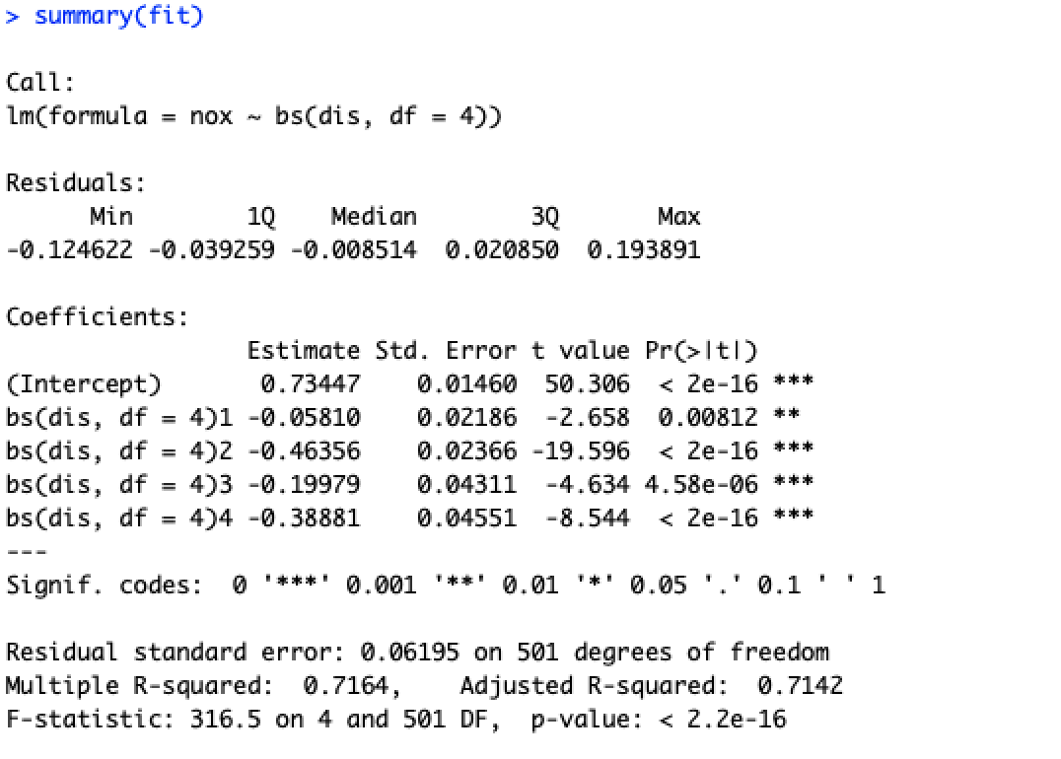

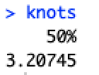

The Knots is chosen where the data is dense and changes behavior. since the degree of freedom is 4 there is one knot at 3.20745



**(e) Now fit a regression for a range of degrees of freedom, and plot the resulting fits and report the resulting residual sum of squares. Describe the results obtained.**

|  |
| --- |
| rss <- rep(1, 12)  plot(dis, nox)  color=c("red","blue","green","yellow","black","grey","orange","brown","pink","purple")  for (i in 3:12) {  fit <- lm(nox ~ bs(dis, df = i), data = Boston)  lines(sort(dis), fitted(fit)[order(dis)], col=color[i-2])  rss[i] <- sum(fit$residuals^2)    }  **l**egend("topright",legend=c("polynomial 3rd degree of freedom","polynomial 4th degree of freedom","polynomial 5th degree of freedom","polynomial 6th degree of freedom","polynomial 7th degree of freedom","polynomial 8th degree of freedom","polynomial 9th degree of freedom","polynomial 10th degree of freedom","polynomial 11th degree of freedom of freedom","polynomial 12th degree of freedom") ,col=c("red","blue","green","yellow","black","grey","orange","brown","pink","purple") , lty =1 , lwd =2 , cex =.8)  rss  which.min(rss) |



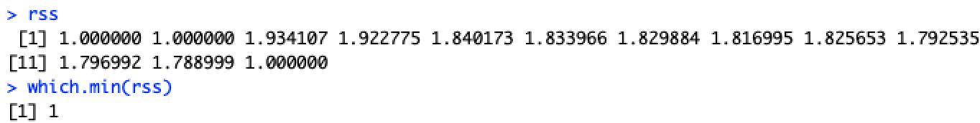

The degree of freedom is plotted for 3 to 12 degree with the minimum residual sum of squares for 3,4th degree

**(f) Perform 5-fold cross-validation to select the best degrees of freedom for a regression spline on this data. Describe your results**

|  |
| --- |
| cv.error=rep(1,10)  for (i in 3:10){    glm.fit=glm(nox~bs(dis,df=i),data=Boston)  cv.error[i]=cv.glm(Boston,glm.fit,K=5)$delta[1]  }  cv.error  glm.fit$rank  which.min(cv.error)  min(cv.error) |

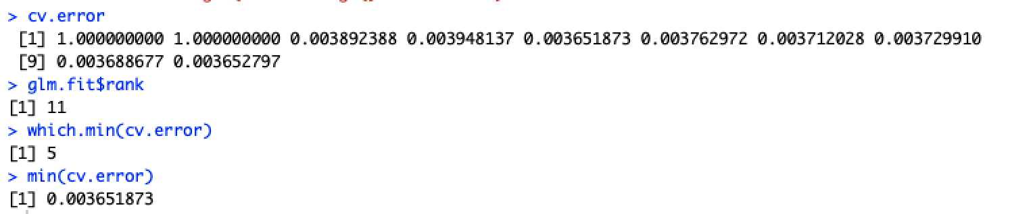

5 fold cross validation is performed on degrees from 3 to 10 and minimum cv.error comes up for 7th degree of freedom. So it is the best degree of freedom.

**3. (For graduate students only) Reproduce Figure 5.3 on page 145 of \The Elements of Statistical Learning". Explain how you obtain the figure.**

A uniform distribution is created with min=0 and max=1. A polynomial Y is created with beta Coefficients for X. Now a cubic spline is fitted for degree of freedom as 6 as given. Now pointwise variance is calculated. For natural cubic spline the boundary knots are defined as given at 0.1 and 0.9 with 6 degree of freedom. And similarly pointwise variance is calculated. Similarly it is done for polynomial and linear fit and all the plots are plotted in one plot.



|  |
| --- |
| n=50  x0=runif(n,0,1)  x0=sort(x0)  X=cbind(1,x0,x0^2,x0^3)  eps=rnorm(length(x0))  beta <- c(4.3965,1.9407,-0.1215,0.1535)#assumed true coefficients  Y=X%*%beta+eps  ###cubic spline  N=bs(x0,knots=c(0.33,0.66),degree =6)  N=cbind(1,N)  H=N%*%solve(t(N)%*%N)%*%t(N)  yhat_1=H%*%Y  sigma2_1=(1/(n-ncol(N)))*sum((yhat_1-Y)^2)  var1=diag(H)  ###natural cubic spline  v=seq(0.1,0.9,length=6)  N2=ns(x = x0,knots = v[2:5],Boundary.knots = c(0.1,0.9),df = 6)  H2=N2%*%solve(t(N2)%*%N2)%*%t(N2)  yhat_2=H2%*%Y  sigma2_2=(1/(n-ncol(N2)))*sum((yhat_2-Y)^2)  var2=diag(H2)  #ploynomial fit  P=poly(x0,3)  H3=P%*%solve(t(P)%*%P)%*%t(P)  yhat_3=H3%*%Y  sigma2_3=(1/(n-ncol(P)))*sum((yhat_3-Y)^2)  var3=diag(H3)  #global linear  X1=cbind(1,x0)  H4=X1%*%solve(t(X1)%*%X1)%*%t(X1)  yhat_4=H4%*%Y  sigma2_4=(1/(n-ncol(X1)))*sum((yhat_4-Y)^2)  var4=diag(H4)  minY=min(var1,var2,var3,var4)  maxY=max(var1,var2,var3,var4)  plot(x0,var1,pch=20,type='b',ylim=c(minY,maxY+0.1),col="green",  xlab = "X",ylab = "pointwisevariance",main = "Pointwise variance curves")  lines(x0,var2,pch=20,type='b',col="blue")  lines(x0,var3,pch=20,type='b',col="red")  lines(x0,var4,pch=20,type='b',col="orange")  legend("top",legend=c("cubic spline","natural cubic spline","polynomial fit","global linear"),  col=c("green","blue","red","orange"),lty=2) |

**4. Consider the Auto dataset in the R package ISLR. Let mu be the population mean of mpg and mu-med be the population median of mpg**

**(a) Provide an estimate of mu**.

|  |
| --- |
| library(ISLR)  auto_df=data.frame(Auto)  attach(auto_df)  mpg.mean =mean(mpg)  mpg.mean |



the estimate of mu is 23.44592

**(b) Estimate the standard error of ^using bootstrap.**

|  |
| --- |
| boot.fn = function(data, index) return(mean(data[index]))  library(boot)  bstrap = boot(mpg, boot.fn, 1000)  bstrap |

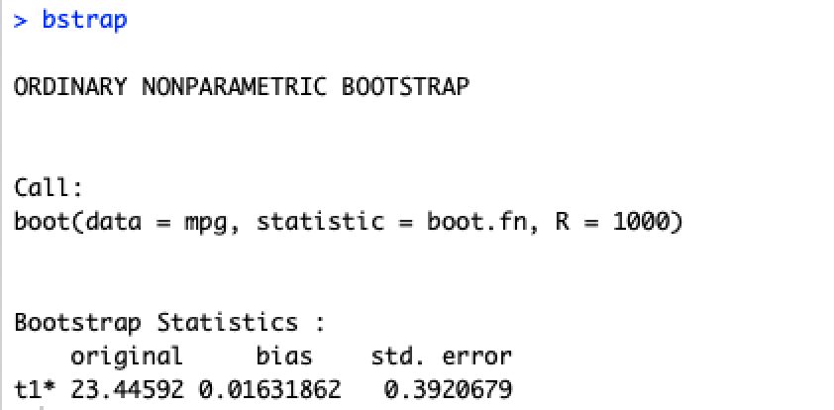

**standard error of mu comes as 0.3920679**

**(c) Based on the result in (b), provide a 95% confidence interval for**

|  |
| --- |
| **c**(bstrap$t0 - 2 * 0.3890956, bstrap$t0 + 2 * 0.3890956) |

**95% Confidence is given by:-**



**(d) Provide an estimate of med.**

**Estimate the standard error of ^med using bootstrap.**

|  |
| --- |
| mpg.median =median(mpg)  mpg.median  boot.med.fn = function(data, index) return(median(data[index]))  bstrap.med = boot(mpg, boot.med.fn, 1000)  bstrap.med |



**Estimate of median is 22.75**

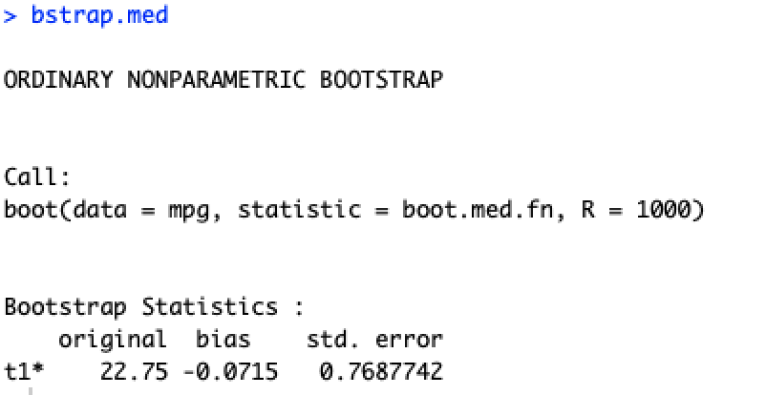

**The standard error comes as 0.7687742**

**(e) Based on the result in (d), provide a 95% confidence interval formed.**

|  |
| --- |
| c(bstrap.med$t0 - 2 * 0.7652976, bstrap.med$t0 + 2 * 0.7652976) |

**The 95% confidence interval is given by:-**



**Solution 5**

**(a)**

The number of data points in this simulated data is n=100

and number of predictors is p=2.

The model is formed by the model

The X and Y are given below

|  |
| --- |
| set.seed(100)  y = rnorm(100)  x = rnorm(100)  y = x - 2 * x^2 + rnorm(100) |

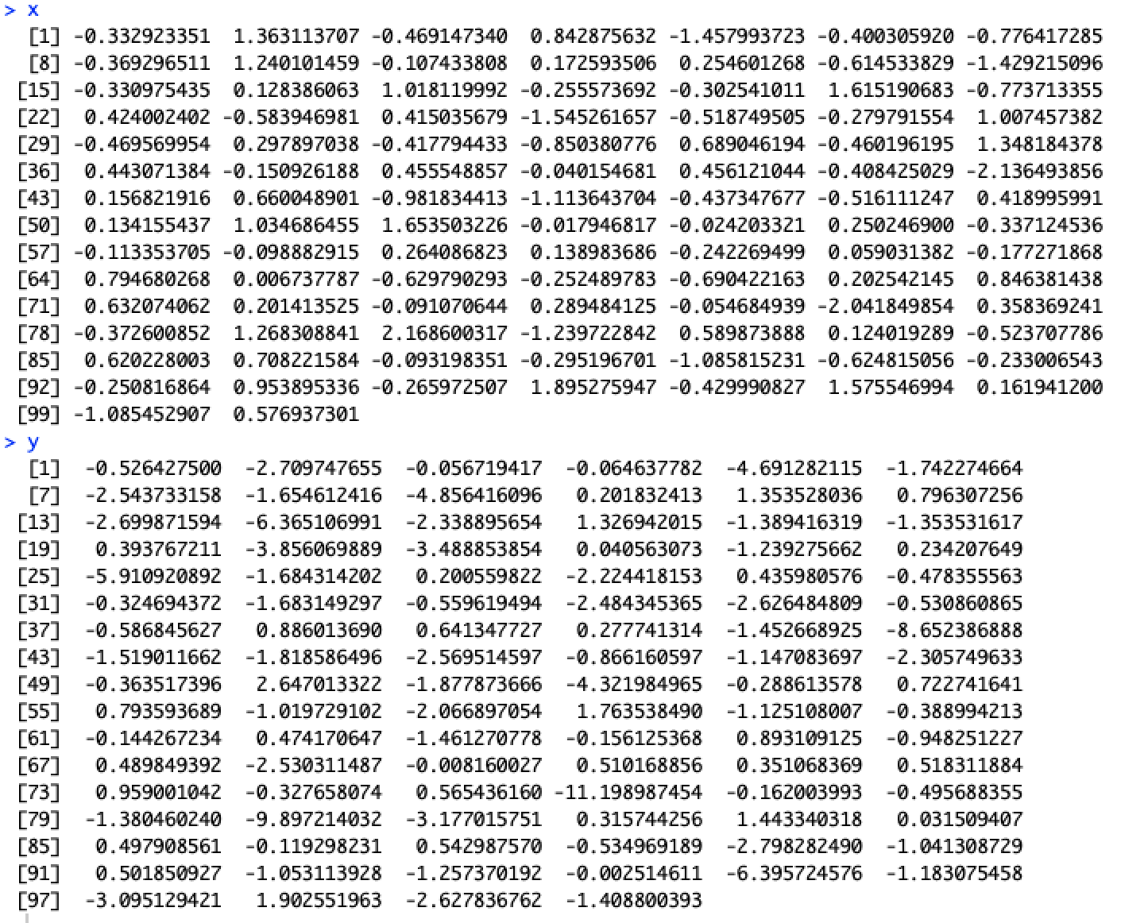

**(b)**

we could see a quadratic relationship from the plot as it curves. We can see from the equation of the model also it should behave like quadratic only.

|  |
| --- |
| plot(x, y) |



**(c)**

|  |
| --- |
| new.data = data.frame(x, y)  glm.fit = glm(y ~ x)  cv.glm(new.data, glm.fit)$delta  glm.fit = glm(y ~ poly(x, 2))  cv.glm(new.data, glm.fit)$delta  glm.fit = glm(y ~ poly(x, 3))  cv.glm(new.data, glm.fit)$delta  glm.fit = glm(y ~ poly(x, 4))  cv.glm(new.data, glm.fit)$delta |

The cross validation errors of all the models are given in the below figure :-

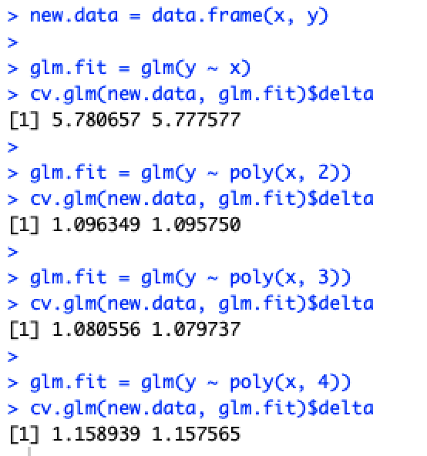

**(d)** We change the seed to 10 and reproduce the same code again to find the cross validation as given below :-

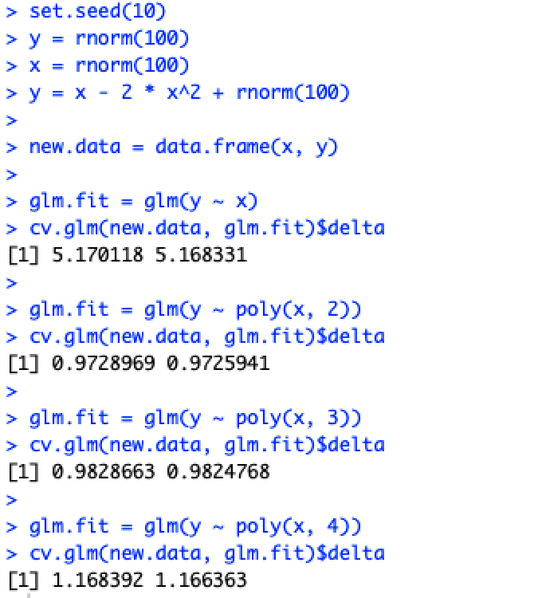

Both the results are identical since LOOCV evaluates n folds of a single observation. Every time it leaves one observation as output and all other observations as input and hence the results are similar.

Also model for quadratic has lowest cv error if we consider both the seeds. To confirm this observation we check it on other seed values as well and find that model with quadratic term has the lowest value of cv error. We expect this because because relation between the variable is quadratic.

**(e)**We can see that the model that quadratic and the linear terms are more significant than the 3 ,4th power which should be case as we know the model is quadratic.

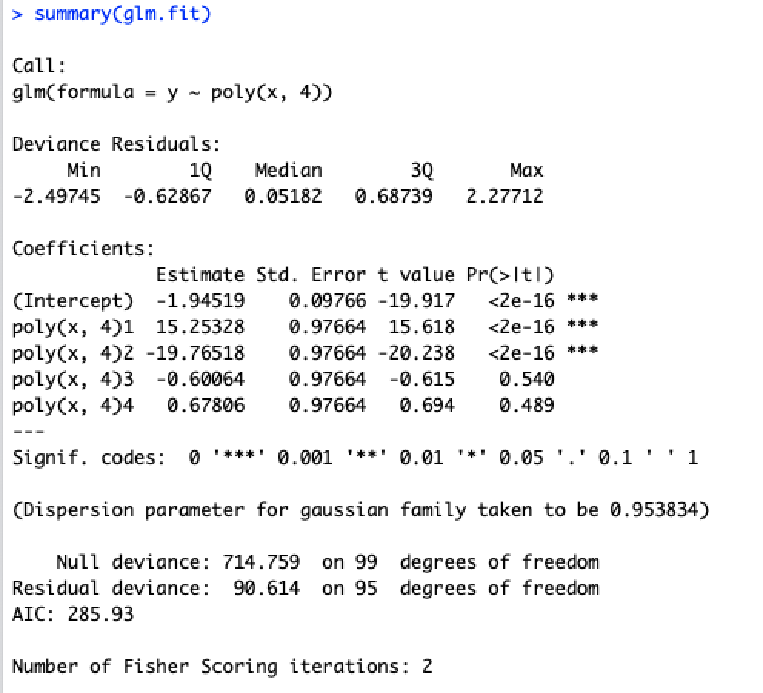

**Solution 6**

|  |
| --- |
| fsample<-function(mu,sigma,n,nsim,alpha)  {  xbar<-rep(0,nsim);x_sd<-rep(0,nsim);flag=0  for(i in 1:nsim)  {  set.seed(i)  # x contains a random sample of size n of the variable X  x<-rnorm(n,mu,sigma)  xbar[i]<-mean(x)  x_sd[i]<-sd(x)  cat('sample mean:',xbar[i],"\n")  cat('Confidence interval for sample mean:',xbar[i] - qnorm(1-(alpha/2)) * x_sd[i], xbar[i] + qnorm(1-(alpha/2)) * x_sd[i],"\n")  if((mu<xbar[i] + qnorm(1-(alpha/2)) * x_sd[i]) && (mu>xbar[i] - qnorm(1-(alpha/2)) * x_sd[i])){  flag=flag+1  }  }  cat('Coverage:',flag/nsim,"\n")  }  fsample(2,sqrt(5),10,1000,0.05)  fsample(2,sqrt(5),10,1000,0.025)  fsample(2,sqrt(5),100,1000,0.05)  fsample(2,sqrt(5),100,1000,0.025)  ################## c  fsample<-function(mu,n,nsim,alpha)  {  xbar<-rep(0,nsim);x_sd<-rep(0,nsim);flag=0  for(i in 1:nsim)  {  set.seed(i)  # x contains a random sample of size n of the variable X  x<-rnorm(n,mu)  xbar[i]<-mean(x)  x_sd[i]<-sd(x)  cat('sample mean:',xbar[i],"\n")  cat('Confidence interval for sample mean:',xbar[i] - qnorm(1-(alpha/2)) * x_sd[i], xbar[i] + qnorm(1-(alpha/2)) * x_sd[i],"\n")  if((mu<xbar[i] + qnorm(1-(alpha/2)) * x_sd[i]) && (mu>xbar[i] - qnorm(1-(alpha/2)) * x_sd[i])){  flag=flag+1  }  }  cat('Coverage:',flag/nsim,"\n")  }  fsample(2,10,1000,0.05)  fsample(2,10,1000,0.025)  fsample(2,100,1000,0.05)  fsample(2,100,1000,0.025) |

**Part 1**



**Part 2**

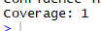

**Part 3**



**Part 4**



**(c)**

**Part 1**



**Part 2**



**Part 3**



**Part 4**



The results are same.